About Tandelyn Atkinson Weaver
Tandelyn Atkinson Weaver is an inspirational and motivational Professional and Business Coach who speaks powerfully about the simple truths of discovering your greatness and power within. Innovative and imaginative, she is committed to providing mechanisms and systems to encourage, empower and improve upon your ability to handle, in a very positive and purposeful way, those inevitable challenges which you will face during a lifetime.
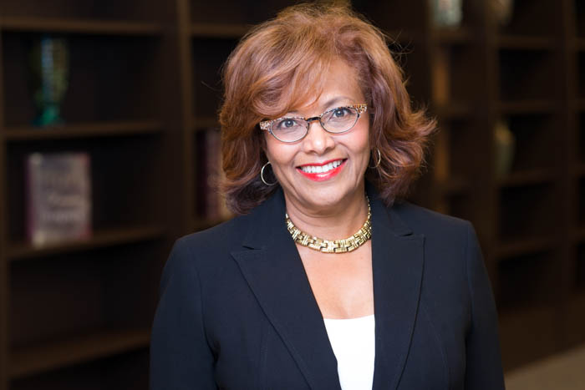
Tandelyn represents a new generation of coaching, grounded in a keenly defined sense of family and spiritual values, based on Christian principles and sound business policies. She is committed to imparting a sense of esteem, accomplishment, achievement and vision.
Tandelyn offers a person various messages embodying the them, “The Power of Positive Action.” She redirects your journey from wishing, wanting, hoping and dreaming to action-oriented, goal attainment and positive achievement, all for the specific purpose of empowering you.
Revolutionizing your way of thinking, Tandelyn helps you to view challenges as opportunities to strengthen your faith, courage and commitment. She eloquently inspires and captivates you. You will enjoy and benefit from her years of experience as an executive, team leader, the mother of two children and the wife of a successful physician.
Tandelyn is knowledgeable in the corporate, non-profit and entrepreneurial sectors of business. Her career encompasses investment banking, finance, management, marketing, and sales. Currently, she is the Executive Director for the Kingdom Builders’ Center, Houston. In the past she worked for several Fortune 500 companies including Citibank (NYC), IBM (NYC), and Merrill Lynch (Houston). For 15 years, she was the administrator of Advanced Laser and Cosmetic Dermatology, where she managed a staff in 2 locations. Tandelyn also served as the Houston City Director and Executive Coach for Coachville, LLC, a premier coaching company with over 60,000 members.
As the President of The Power of Positive Action, she is a Certified Professional and Executive Coach and an Inspirational and Motivational Speaker.
Tandelyn receiver her MBA in finance and Marketing from The Wharton School of Business at the University of Pennsylvania and her BA in Economics from Spelman College, Atlanta, GA. She is married to a Dermatologist and has two adult children.

Engaging in a coaching relationship with Mrs. Weaver has been one of the best decisions I’ve ever made. She immediately coached me through the process of developing both a plan and the appropriate mindset to finish a project on which I had previously made little progress. Additionally, she has helped me challenge myself, identify new goals and make progress toward their completion. Her coaching skills are second to none, plus I fell as though I’ve gained a lifelong friend and mentor. V. Johnson
“You are a wonderful business coach. My session with you has made all the difference in terms of saving my business! You brought me from pessimism to optimism. Where there was confusion, there is now clarity. I see new approaches and how I can develop a strategy to make my business more competitive in the market place. You are truly gifted. Thank you. Thank you!” S. Osazee
“You really made me stretch and think about what I really wanted. It was introspective and valuable. People in corporate America need this.” L. Brooks.

